WSP-12135 Map Improvements

WS-P 23.12.Zanskar: To support Map functionality in WS-P.

|  |  |  |  |
| --- | --- | --- | --- |
|  | | |  |
| Author | Gaurav Kumar |
| Contributor | Gaurav, Kiran |
| Organization | Nokia |
| |  |  |  |  |  |  |  |  |  | | --- | --- | --- | --- | --- | --- | --- | --- | --- | | **Change History**   |  |  |  |  | | --- | --- | --- | --- | | **Version** | **Date** | **Author** | **Description of changes** | | 1.0 | 24/07/2023 | Gaurav, Kiran | Initial Draft for map improvement | | |  | |  | | Contents  1 Feature Overview 2  1.1 Summary 2  1.2 Requirements 3  1.3 Design Considerations 3  1.3.1 Impacted areas 5  1.4 Configuration Information 8  1.5 Target Customer and Customer Network (if available) 8  2 Design Overview 8  2.1 Assumptions 8  2.2 Constraints 8  2.3 Risks 9  2.4 Functional Areas covered by the design 9  2.4.1 Use Cases 9  2.4.2 Feature/Sub-feature Enabling 9  2.4.3 Limitations 9  2.5 Operation Workflow 9  2.5.1 Geo-free improvement 9  2.5.2 Geocoding improvement 9  2.5.3 Google map improvement 10  2.5.4 Layer View and show route improvement. 10  2.6 Process/Functional Flow 10  2.6.1 Geocoding improvement 10  2.6.2 Enable map setting improvement 10  2.6.3 Geo-free view improvement 11  2.6.4 Layer View improvement for cascade configuration 11  2.6.5 Show Route improvement for cascade configuration 11  2.7 EPT Engine Dependencies 11  2.8 Object and Data Model 11  2.9 Solution Context/GNP 11  2.10 Configuration Data 12  2.11 Persistence 12  2.12 Database 12  2.13 Data Migration/Upgrade 12  2.14 Design Features 12  2.14.1 Performance 12  2.14.2 Scalability 12  2.14.3 Security 12  2.14.4 Concurrency 12  2.14.5 Error/Exception Handling 12  2.14.6 Disaster Recovery 12  2.14.7 Transaction Strategy 13  3 User Interface Design 13  3.1 Geo-free view improvement: 13  3.2 Layer View and Show Route for cascading configuration 13  3.3 Geo map improvement 14  3.4 Geocoding improvement 15  4 REST Interface 16  4.1 Enable map setting improvement 16  4.2 Geo free view improvement 16  4.3 Geocoding improvement 16  4.4 Layer View and Show Route for cascade configuration 16  5 Test Strategy 16  6 Open Issues 17  7 Appendix 17  8 Review Comments 17 | | |  |
|  | | |  |

General Instructions

Basic Requirements:

Include a Table of Contents

All sections, including headings, subheadings, and tables, must be included, and filled in.

If some section is not applicable, explicitly identify that with “Not Applicable”.

If something is yet to be determined or otherwise under investigation, indicate that and reference the Jira ticket under which this will be determined with the ticket key as a hyperlink and the ticket title/summary indicated. If there is no Jira ticket explicitly covering the open item, create one (likely a sub-task under a story).

Make sure to verify all the checklists for use-cases, components, and network configurations.

Proofread for typos and grammatical errors before review.

Note format for Jira ticket references: <hyperlinked key>: <*Jira Summary*>

For example, [WSP-508](https://optics-jira.ext.net.nokia.com/browse/WSP-508): *Infrastructure*

# Feature Overview

This Epic [WSP-12135](https://optics-jira.ext.net.nokia.com/browse/WSP-12135) supports the Map functionality in WS-P.

## Summary

This EPIC provides the map improvement functionalities for the selected design. It also covers the following and its functionalities which are supported in 23.7.H:

* Enable map setting improvements
* Geo free improvements
* Geo Coding improvements
* Layer view and show route for cascade configuration.

## Requirements

* Enable map setting improvement – It will support 2 tile layers which are Google map and Open Street map under map settings. Based on selected tile layer it will display relevant map in UI.
* Geo-Free view improvement – It will allow user to create site and edit site in outside of the map boundary.
* Geo-coding improvements – It will support taking coordinate and providing address. It will include site creating using swagger in normal mode as well as fast mode.
* Support the Layer View and Show Route for Cascade Trail Routed Over another Cascade Trail and remove the "Unsupported Configuration" error message.

## Design Considerations

|  |  |  |  |
| --- | --- | --- | --- |
| Area | Applicability (Y/N) | If not applicable, why not? | If yes, which section covers |
| Data Model Usage (WS-P and/or EPT) | Y |  | We are using existing data model only in Geo coding, Layer view |
| Data Model Changes (WS-P and/or EPT) | N |  |  |
| EPT Engine Support | Y |  | Require support for Show Route,  Layer View |
| Network Configuration (Nodes, Cards, NEs, Interworking) | N |  |  |
| Version Mix of the Nes | N |  |  |
| Scale (Size of network, # of connections, # of TPs). | N |  |  |
| Upgrade (Design & Release) | N |  |  |
| Migration | N |  |  |
| Data persistence – Process/Container/VM Restarts | N |  |  |
| Greenfield/Brownfield | N |  |  |
| Concurrency (Process and/or Thread) | Y |  | Fast Mode Creation |
| Resource Utilization/Footprint | N |  |  |
| Data Integrity | N |  |  |
| Performance | Y |  | Fast Mode Creation,  Layer View, Show Route |
| HA/DR | N |  |  |
| External Interfaces | N |  |  |
| User Activity Logging | N |  |  |
| Jobs | N |  |  |
| User Experience   * Ease of Use/Workflow * Consistency | N |  |  |
| Overflow Control | N |  |  |
| Boundary Conditions | N |  |  |
| Error/Exception Handling | Y |  |  |
| Naming in Code (Classes, Interfaces, etc.) | Y |  |  |
| REST Interface changes   * Impacts to clients * Backward compatibility | Y |  |  |
| Data backup (including data and config files) and overflow strategy | N |  |  |
| User Type & Permissions | Y |  | Geocoding improvement |
| SW & SVT Testing | Y |  |  |
| Dependency on Existing features (and assumptions about how those features work for the epic to work). | Y |  | Fast Mode Creation |

### Impacted areas

|  |  |  |  |
| --- | --- | --- | --- |
| Functional Area | Impacted or not | If not, why not | If impacted, describe |
| Network Specification   * Solution Context/GNP * Topology Specification * (Multi-Layer) Trail/Service Specification * Import (EPT, WP, Excel) * Templates | No |  |  |
| Plan/Design Management   * Plan CRUD Operations * Design CRUD Operations * Import WS-P Design * Export WS-P Design * Check In/Check Out/Revert Design * Clone Design | No |  |  |
| Design Operations   * Remove Design * Auto Design * Verification * Design State Calculation * Manual Routing/Edit Route * Link Optimization * Channel Management * Bandwidth Defragmentation | No |  |  |
| Auto Design Solution   * Design Prep/Freeze Support * Routing * Wavelength Assignment * Equipment Selection * Power/Gain/Equipment Settings * Physical Realization * Verification | No |  |  |
| Manual/Edit Design   * Create/Edit Route * Path Analyzer * Wavelength Assignment * Equipment Selection/Edit * Power/Gain/Equipment Settings * Physical Equipment Edit * Verification | No |  |  |
| Visualization/UI   * Map   + Layer View   + Heat Map   + Route View   + NRA Support   + Object & Template Support * Design App Tables * Object Create/Edit Panels * NE Edit Panel * OMS Panel * Node Panel * Schematic Panel * CPLR * Channel Utilization | Yes |  | Layer view, show route and Map |
| Reports   * Network Information Report * Equipment Report/Card Inventory report/Rack report * BOM Report * Installation Report * Physical Layer Report * OT Segregation/ASE Noise Report * Table Information report * Visio Report * Available Resources Report * Channel Utilization report * Log Report | No |  |  |
| GMPLS   * Failure Scope/Sequence Management * SRG Management * GPC Management * NRA/GMPLS Audit * GMPLS Report | No |  |  |
| Network Lifecycle   * Commissioning * Upload (EPT Style) * Create Design from NDF (WP Style) * Discrepancy Report * Merge with Deployed Actualization * Network Audit * Backward Compatibility/NE Upgrade | No |  |  |
| Infrastructure   * Jobs * Logging * Notifications * Error Management * Multi-Instance * Session Management * Performance * Scalability * Security * EPT Cut-Through * Process Management/Monitoring | Yes |  | Depends on Notifications  Error Management, Scalability, Performance, Security |
| Data Model/DTO & Associated Operations   * Site * NE/Shelf/Pack * Node * Segment (Span in WP) * WDMLink/OMS * Span (OTS in WP) * System * Transparent Link/OCH * Trail * Service * Error * Failure Scenario/SRG * Phase/Project | No |  |  |
| OA&M   * User CRUD * User Type/Permissions/Auth * User/Design Management/Sharing * DB Management * Persistence * Installation * Start-up * Release Upgrade * Licensing * Backup/Restore * High Availability/Disaster Recovery | No |  |  |
| Configuration Data Management   * CDS * Configuration Files (EPT or WS-P) * Price file | No |  |  |
| REST Interface   * Standard * Client-specific * Public/Private * Swagger Support * Programmatic Client Support | Yes |  |  |
| User Documentation | Yes |  |  |

## Configuration Information

NA

## Target Customer and Customer Network (if available)

All the customers supported.

# Design Overview

## Assumptions

N/A

## Constraints

For Geo coding improvement, we need to use Google service provider to address in English rather than local language. But Google is a paid service provider and not free to use or test. As current service provider like Bing, MapQuest does not support English as language instead provide in local language.

## Risks

N/A

## Functional Areas covered by the design

Map improvement involves all existing functionality of the map as well as new improvement listed under use cases below.

### Use Cases

* Enable map setting with google map.
* Site creation outside boundary in Geo free view.
* Site creation with address through Swagger.
* Site creation with address through fast mode.
* Layer View for cascade configuration.
* Show Route for cascade configuration.

### Feature/Sub-feature Enabling

* Fast mode
* Swagger

### Limitations

N/A

## Operation Workflow

Map improvement covers the below listed operations along with existing map functionalities. Each operation is covered in below sections with details.

### Geo-free improvement

Geo-Free view improvement will allow user to create site and edit site in outside of the map boundary.

### Geocoding improvement

In UI there will be no change with existing screens which are supported earlier.

In backend there will be no new API created, only existing APIs are modified and reused for this improvement.

From swagger it is required to pass validate and geocoding value true for site to be created. Also, we need to activate geo coding service provider.

* Implemented a method from 3rd party service to validate the address from swagger.
* Implemented site creation with valid address from Swagger.
* Implemented site creation with valid address for fast mode from Swagger.
* Import/export excel with Geo coding address.

### Google map improvement

We need to add new tile layers like displaying Google map and Open Street layers. Inside these tile layers there will be different options to have a view.

In UI there will be 2 new accordions introduced which will have different types of layers. Under each accordance there will be relevant tiles added with these tiles user can select and open the map.

From API perspective there is no change required to accommodate this improvement.

Along with this there will be no DB modification required.

### Layer View and show route improvement.

Layer view and show route for cascade configuration scope support.

* Refactoring show route.
* Refactoring layer view.
* Cascade configuration.
* L band OT and DUAL carrier.
* Restructure layer view in OPS.
* Remove the "Unsupported Configuration "error message.
* Circuit packs supported - MLSB, PSC, ASC4, MXN.

## Process/Functional Flow

### Geocoding improvement

**Condition**: In normal mode from swagger validate and geocoding need to be true.

Users can now create sites based on address.

**Condition**: In normal mode from swagger validate need to be true and geocoding need to be false

Users can now create sites based on coordinates.

**Condition**: In fast mode, need to activate geo coding service provider

Users need to navigate on UI for site creation. Once successful site creation, users can now navigate to edit sites. There in geo coding address will be populated.

### Enable map setting improvement

**Condition**: Map should be loaded in geo view mode, under map settings it should have enable map checkbox checked.

* User can select any one option any point of time to view respective map.
* User can toggle accordance to see and select any tile options.
* User can have scrollbar if options under map settings overflow.

### Geo-free view improvement

**Condition**: Map should be in geo free view and user click outside map boundary

The geo free coordinates will be maintained internally and not shown to the user.

Geo-Free view improvement will allow user to create site and edit site in outside of the map boundary.

### Layer View and show route improvement for cascade configuration

**Condition**: Run design need to be completed/success.

For show route cascading: -

* Trail will display the route same as under laying trail for protected/unprotected.

For layer view cascading: -

* The label associated to working/protecting route is not necessary -> Need to delete.
* The “Protected Trail” – should be displayed on top of the layer view and terminated on the OT cards.
* The working and protecting trails should be terminated on the OPSUM functional block.

## EPT Engine Dependencies

For Layer view and show route data will be retrieved from EPT engine.

## Object and Data Model

No new API has been introduced and we will be using existing APIs only.

## Solution Context/GNP

NA

## Configuration Data

NA

## Persistence

NA

## Database

NA

## Data Migration/Upgrade

NA

## Design Features

### Performance

Applicable for Layer View, Show Route, Fast Mode Creation.

### Scalability

NA

### Security

Applicable for all operations.

### Concurrency

Applicable for fast mode operations.

### Error/Exception Handling

Applicable for all operations and will adopt the WS-P Architectural approach.

### Disaster Recovery

NA

### Transaction Strategy

NA

# User Interface Design

The UI interface will be the same as. The screenshots below are with a few changes in accordance with the improvements.

## Geo-free view improvement:

Users try to create site outside the boundary of the Map-> able to create site.

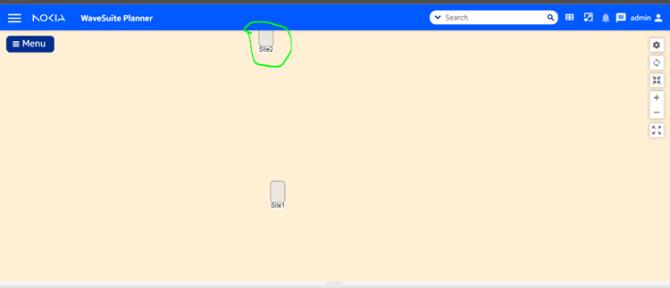

## Layer View and Show Route for cascading configuration

Show route

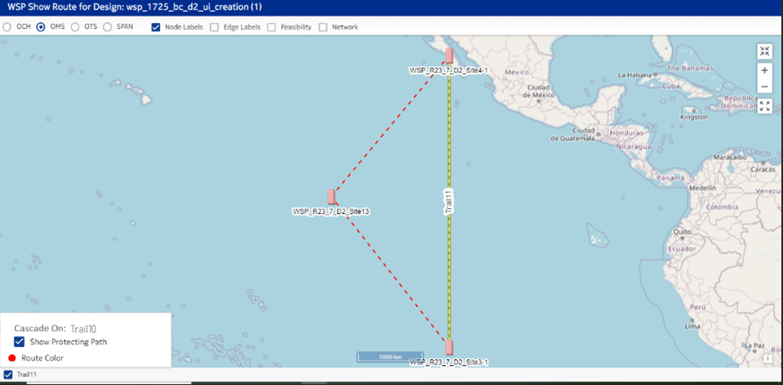

Layer view

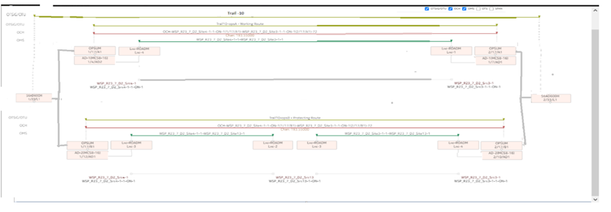

## Geo map improvement

Users can see Google map accordance under enable map setting. Under this section there will be multiple tiles option for selection.

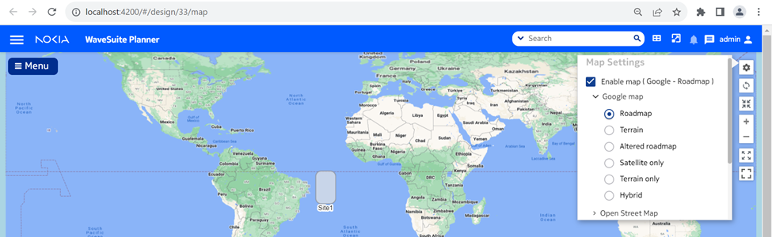

Users can see Open Street map accordance under enable map setting

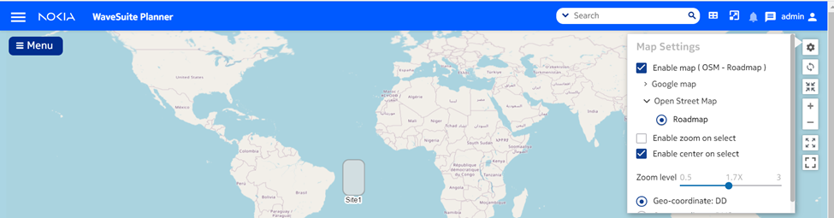

## Geocoding improvement

No UI changes required.

# REST Interface

## Enable map setting improvement

Will be using existing API only and there will be no new API introduced in this improvement.

## Geo free view improvement

Will be using existing API only and there will be no new API introduced in this improvement.

## Geocoding improvement

Will be using existing API only and there will be no new API introduced in this improvement.

## Layer View and Show Route for cascade configuration

Will be using existing API only and there will be no new API introduced in this improvement.

# Test Strategy

The use cases will be tested using Cucumber Feature.

Show route and layer view for cascade configuration:

* Will be checking routes API returning correct response data.
* Will be checking show route region case.

Geo coding improvement

* Will test site creation with address using swagger.
* Will test the fast mode API.
* Will ensure the entities are created properly with fast mode.

Enable map setting improvement

* Will be checking only user preferences saved while switching between tiles.

Geo free view improvement

* Features can only be tested using UI unit test case.

# Open Issues

* Google license key for map tile layer needed.
* We tried to analyze the possibility of getting address in English rather than local language. So, we found that free service provider does not provide address in English language and only Google which is paid one have this feature. We have added parameter to handle address in English.
* Layer view and show route for cascade configuration NOT support in this epic release: -
  1. Protection types other than OPS.
  2. OMSP trails.
* TOADM and DFOADM configuration are not supported for layer view.

# Appendix

NA

# Review Comments

Track all the review comments here.